CV
Abdullayev Mirfazil Qafar 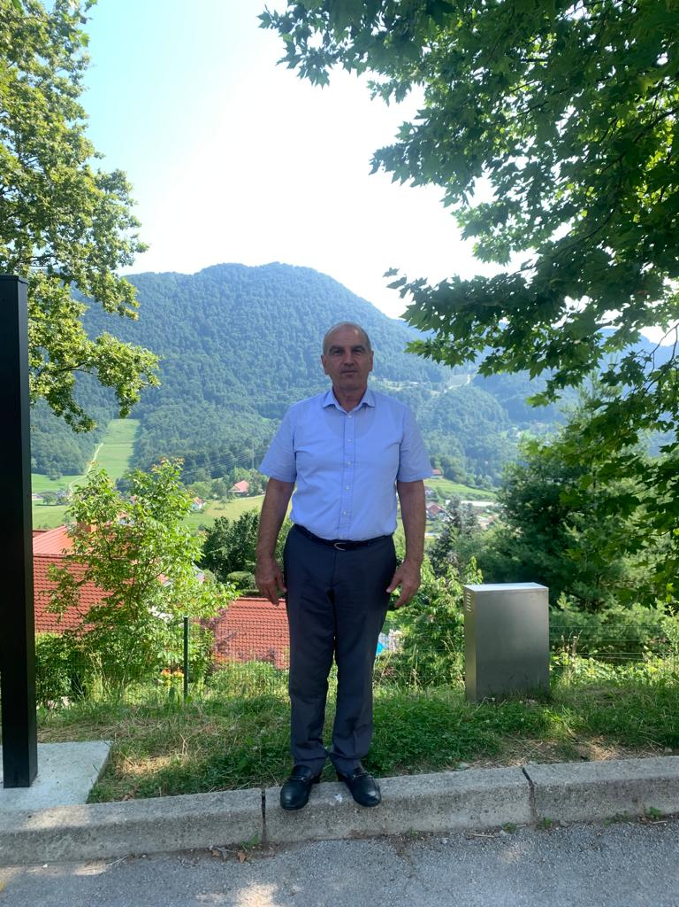
Personal information
Name, Surname: Mirfazil Abdullayev
Adress: Baku city, M.Qasımov street.,h. 3, ap.84
Tel.: 050-366-36-08
E-mail: m.fag0408@gmail.com
Nationallity: Azerbaijani
Date of birth: 08.03.1960
Marital status: Married
Work experience:
20.04.1990 — 13.08.2001 Leading scientific worker at the Laboratory of Infectious Diseases and Biotechnology of Azerbaijan Veterinary Scientific Research Institute.
13.08.2001 —24.11.2015 Deputy Director of Azerbaijan Veterinary Scientific Research Institute.
25.11. 2015 -01.08.2018 Head of Biological preparations control department
From 01.08. 2018 until to now Head of the Department of Expertise of Normative-Technical Documents on Veterinary Medicines of the Azerbaijan Food Safety Institute
Description: Investigation and treatment of respiratory diseases, peptic and metabolic disorders of calves. Scientific research work in the field of studying infectious diseases of livestock, preparation of treatment preventive measures since 2011
Basic qualifications:
- Specialist, who has experience in treating and treatment of diseases of respiratory, gastrointestinal and metabolic disorders of calves
- Researcher for the study of infectious diseases of livestock since 2011 and the preparation of treatment preventive measures
- Professional experience - 32 years
- Total job experience - 39 years
- Currently, working on the doctoral dissertation (since 1993)
- Contribution Grant Program (2003-2005), co-authored by the project "Complex system for improving animal welfare and treatment and prophylaxis of non-infectious diseases".
- Working as examination controller from 2010 to the present day in the State Commission for Student Admission.
- Biological Co-operation Program (BCP) "Epidemiology and Epizootology Basics" - Trainer (January 2015 – december 2015)

Education:

Educational institution: (date) | Specialization
Odessa Agricultural Institute, Veterinary (1979-1984) | Veterinarian
Odessa Agricultural Institute, Veterinary, Ph.D. (1986- 1989) | Ph.D. in veterinary

Professional experience:
• Participation at the conference held at the All-Russian scientific-research experimental veterinary institute named after Y. Kovalenko in Moscow in 2011.
• In 2013, participation at the international scientific-practical conference, Tbilisi State University, Georgia State Agrarian University.
• In 2014 took part in an international conference Moscow State Veterinary Medicine and Biotechnology Academy named after K. I. Skryabin.
• 2016 (December 16-24) Istanbul, Pendik Institute of Veterinary Control, training in some methods for diagnosing viral diseases (real-time PCR, Konvension PZR, Cultivation of lumpy skin disease virus in various cell cultures, etc.).
• In 2017 (December 15-23) exchange of experience (isolation and identification of rabies virus) at the Research Experimental Veterinary Institute of the National Academy of Sciences of Belarus named after. S. N. Vyshelesky, Minsk.
• In 2019 (June 15-25), Moscow, Rospotrebnadzor, exchange of experience (Stavropol Poultry Plant; Bryansk Meat Processing Plant, TK Miratorg LLC).
• In 2021 (September 19-23), Minsk, the Republic of Belarus, the company "BelVitunifarm" - exchange of experience.
• In 2023 (July 10-15) Sevnica, Republic of Slovenia, Tanin Sevnica company - exchange of experience.
• He has published 33 scientific articles in various local and foreign publications (10 scientific articles in the last 5 years). co-authored 3 books, the author of the 2 recommendations.
Trainings and seminars:
-Took part in the 2-year training course on applied field epidemiology and laboratory management practice, Tbilisi, (2011-2013)
-Took part in the National Workshop on Governance and Roadmap for better inter-sectoral cooperation between country prospects, Animal and human health sectors, Baku. March 13-14, 2014
- Participation in the seminar on advanced development of strategies for promotion, Baku. 16-18 December 2014
- Seminar on Training of Trainers in accordance with Principles of Training of Specialists, Baku. 02-05 March 2015
- Seminar on advanced development of strategies for the success of the project, Baku. May 19-21, 2015
- Biomedical Safety Training Seminar, Baku. 07-10 July 2015
- During his stay in the regions of Azerbaijan, he participated in consultations and seminars organized by veterinarians in regions.
Ability and skills:
Language skills:
Azerbaijani - advanced, Russian - advanced, Turkish - intermediate, English - elementary,
Computer skills:
- Windows, Internet, MS Offıce: Word, Excel, Power Point.

